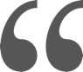

**English**

**German**

**French**

**Trainings**

Management

SAP Solutions

ERP

BW

QIM

*Starting from the business process, functions at the core of the business,*

*to adapt the most efficient and efficient digital solution.*

SAP EXPERT CONSULTANT

TRUSTED ADVISOR ON DIGITAL TRANSFORMATION

**KLARER Jean-Christophe**

[jc.klarer@apteos.eu](mailto:Jc.klarer@apteos.eu)

(+33) (0)6.17.93.53.16

**Education**

Master of Computing

Louis Pasteur University, Strasbourg.

INDUSTRIES

SOLUTIONS

LANGUAGES

TRAININGS & CERTIFICATIONS

**My motto** :

After 16 years with the SAP software company, I decided to place my acquired experience in roles as enterprise architect, solution architect, solution expert as well as my managerial skills in a brand-new company, **my company**.

The proposed services are organized in a portfolio of services focused on business support, consulting, program and project management as well as on digital transformation.

SKILLS

**Certifications**

Enterprise Architect - TOGAF

Design Thinking –

SAP ERP SD & MM

SAP EXPERTISE

* Expert on SAP ERP: SD / CS / MM / PM / PS / CO-PA
* SAP BW / QIM & GTS knowledge
* Solution architect & certified enterprise architect
* Business Process Management, advise on SAP Best Practices
* Solution reviews, audit



C1

B1

Mother tongue

Mother

GTS

CRM

Utilities

Retail

Consumer Products

Discrete Industries

Human resources

* Motivate and revitalize the team, communicate.
* Recognize the performance as well as the non-performance.
* Adapt itself to the diversity of the individualities to cultivate the potential of each.
* Hiring, salary & compensation management, mentoring.

Management

* Management and planning of my team activity, global strategy and objectives
* Establishment of models of engagement of diverse and complex services.
* Establishment of relevant progression paths for team members.
* P&L Management.
* Stakeholder management.

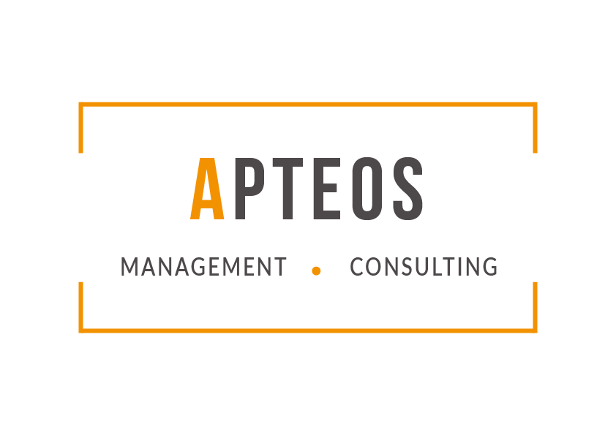

**Founder & CEO - APTEOS Management et Consulting**

Since August 2016

* Daily & long-term management of the company
* Commercial strategy & people management (hiring, staffing, marketing of services …)
* Delivering consulting missions as enterprise architect, solution architect, solution expert, project & change manager.
  + For a Utilities customer, design of a new solution architecture for Maintenance processes, expertise on SAP ERP PS & PM modules, strategic advice on solution architecture.
  + Travel & Transportation company: support on program management – expertise on SAP ERP & GTS, integration between SD & MM processes with SAP GTS. Position papers on several topics.
  + Project management, solution architecture, expertise on SAP Business Suite for several customers

**Industry Consulting Director, Field Service SAP France & EMEA**

July 2009 - May 2016

In charge of 45 people, application consultants & solution architects, my responsibility was to organize & develop the services provided to our customers and to manage the competencies that will be positioned on the market of SAP services: ERP, SCM, CRM & PLM.

* Supply, Demand and Forecast Management (skill gap planning)
* Resource allocation management of Field Services assignments
* Responsible for managing internal projects
* Training needs for strategic areas
* Financial Management Reporting based on Utilization, Forecast, and Budgeting
* Consulting Services Definition & Maintenance
* P&L and Forecast Management
* Internal and external coaching, certified mentor

**Skill manager, Field Service SAP FRANCE**

2007-2010

In charge of Skill Management for the market unit SAP France. In connection with the consulting managers, I managed all the transformation paths related to consulting competences, solutions & industries knowledge. Integration of Business Objects consultants in the consulting department of SAP France. Demand & Forecast management (skill gap planning, workforce planning).

**Platinum Consultant and Solution Architect, Field Service SAP FRANCE**

2005-2009

As certified Enterprise Architect, I evaluate customer requirements, map them to business processes, functional and solution architectures and ensure a proper implementation from a solution architecture point of view.

* Design detailed end-to-end industry-specific / corporate customer to-be processes
* Identify the appropriate end-to-end solution portfolio options and recommendations
* Mainly in High Tech and Discrete industries
* Focus on SAP ERP solutions – SD/MM/PP/FI/CO modules
* Stakeholders management
* Project management:
  + - * 1. - management of a company split
        2. - use of dedicated SAP SLO services, coordination of services
        3. - tests strategy validation
        4. - cut-over management

.

**PROFESSIONAL EXPERIENCE**



**Consultant Expert, Field Service SAP FRANCE**

2000-2005

As ERP, BW and CRM senior consultant my area of responsibilities and tasks were:

* SAP Solution Expert (General & detailed business blueprint, Implementation, creation of test cases, tests scheduling and execution, key users training, go live support, and post go live support)
* Support in escalated projects
* Feasibility studies / solution reviews
* Pre-sales activities
* Focused on **ERP**, SD – MM – CO/PA – PS, **CRM** Sales & Services, **BW** modelling
* Awarded as Best SAP France Consultant in 2004 and 2008
* SAGEM & SAGEM-Communication, SAFRAN Group: High-Tech - Aerospace & Defense: 2000 – 2005
* Solution Expert on SAP ERP: SD, MM, CS, BW, HUM, CRM, CO-PA on several projects:
  + Implementation of Inter Company processes between the French headquarter and the subsidiaries
  + Customer & Vendor consignment between the main warehouse and the worldwide partners
  + Company code merge, redesign of core and context processes, implementation of the new solution, associated reporting
  + New service & maintenance solution: modelisation of business processes, SAP Best practices on service and maintenance order management, integration with sales order management
  + On top of service management processes, implementation of contracts & warranties processes
  + Greenfield project on a brand-new solution dedicated to case and contract management: implementation of an IT solution dedicated to Public sector case and contract management, integration with finance & controling
  + Associated BW reporting, focus on profit center accounting
  + Proof of concept & Blueprint on CRM Sales Express: general & detailed blueprint on a solution dedicated to lead and inquiry management, integration with SAP ERP
  + Implementation of Handling Unit processes, based on SAP ERP-HUM solution
* SIGNATURE SA – Plastic Omnium Group 2004-2005
  + - Implementation of a solution dedicated to case management.
      * Service Management with SAP ERP, CS / MM and SD modules
      * Princing implémentation
      * Adapted Time sheet with CATSXT
      * Integration with Project Management, PS module.
    - Implementation of a new P&L in the company
      * Direct integration of sales orders & projects
      * Budget & real bookings
      * Integration with cost center management

|  |  |
| --- | --- |
| Deliverables | * Functional expertise * Customizing & documentation * Proof of Concept * Upgrade management * Functional coordination and integration, E2E process oriented * Project Management * Change Management |

**PROFESSIONAL EXPERIENCE**

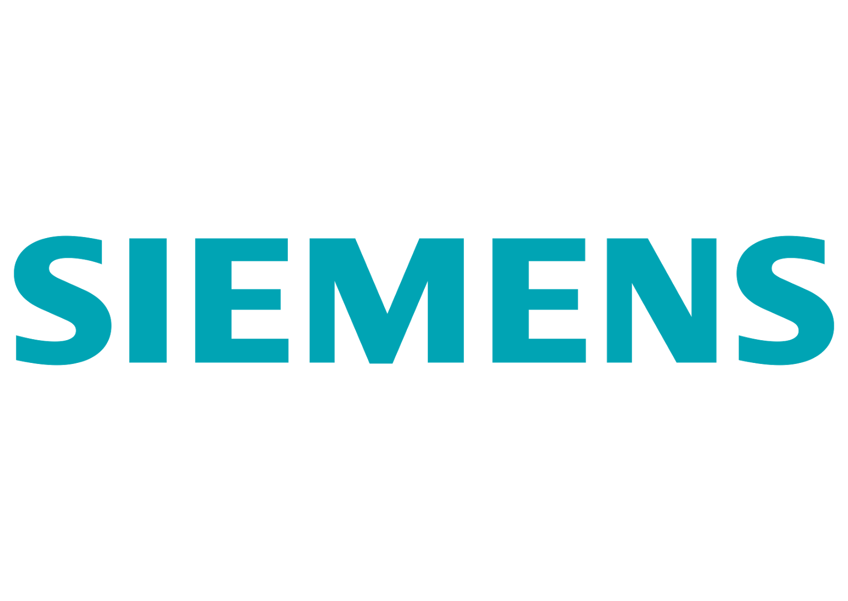

|  |  |
| --- | --- |
| Other SAP experiences with SAP France | |
| Schneider Electric | Solution review on its global and worldwide solution. Focus on SD processes. |
| Dassault Falcon Jet, US | Solution Review on a SAP ERP solution dedicated to maintenance and sales, focus on SD / MM and CS modules. |
| Others | After sales support and expertise on SAP ERP, modules SD, MM and CS  Connection with SAP Active Global Support |

**SAP Expert Consultant, Siemens Business Services**

1997-2000

SAP Consultant & project manager, Consultant & project manager, I managed several projects based on SAP ERP solutions. Focused on SD & MM modules of SAP ERP R/3, I built the first SAP solution architecture of 2 Siemens entities.

Business Process Management.

**Data Exchange Expert, Siemens SAS**

1996-1997

Development & implementation of data exchange protocols between Siemens customers & vendors mainly in High-Tech and Automotive industries.

**PROFESSIONAL EXPERIENCE**